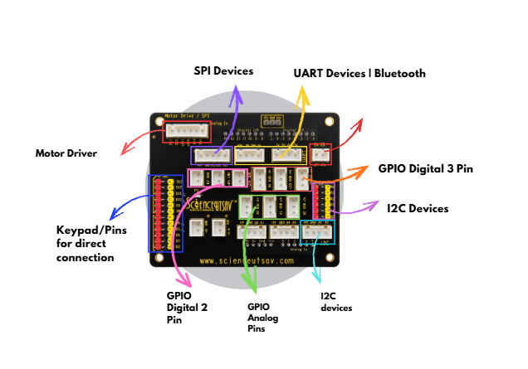

1. Motor Driver
The Motor Driver connector is used to connect and control motors that require more current than an Arduino pin can supply. It allows the Arduino to control the speed, direction, and movement of DC motors and other compatible motors. This connector makes motor wiring simple and reliable by providing dedicated motor output terminals.

2. SPI Devices
The SPI (Serial Peripheral Interface) connector is designed for modules that communicate using the SPI protocol. SPI is a high-speed communication interface used to transfer data between the Arduino and external devices. Common SPI devices include RFID readers, SD card modules, TFT displays, Ethernet modules, and wireless communication modules. The connector includes the required SPI communication pins for quick and organized connections.

3. UART Devices / Bluetooth
The UART (Universal Asynchronous Receiver-Transmitter) connector provides serial communication between the Arduino and external devices. It is commonly used to connect Bluetooth modules (HC-05/HC-06), GPS modules, GSM modules, and serial sensors. UART allows two devices to exchange data through TX (Transmit) and RX (Receive) pins, making wireless communication and debugging easy.

4. GPIO Digital 3-Pin
The GPIO Digital 3-Pin connectors provide Signal (S), Power (VCC), and Ground (GND) in a single connector. This arrangement makes it easy to connect digital components without additional jumper wires. These connectors are suitable for devices such as LEDs, buzzers, touch sensors, IR sensors, relay modules, push buttons, ultrasonic sensors, and servo motors. They help reduce wiring errors and make projects easier to assemble.

5. I2C Devices
The I2C (Inter-Integrated Circuit) connector is used for connecting modules that communicate using the I2C protocol. Only two communication lines (SDA and SCL) are required, allowing multiple devices to share the same bus. This connector is commonly used for LCD displays with I2C adapters, OLED displays, RTC modules, temperature sensors, accelerometers, and other I2C-compatible devices. It simplifies wiring and saves Arduino pins.

6. GPIO Analog Pins
The GPIO Analog Pins are used to connect sensors that produce analog voltage signals. Unlike digital pins, analog pins can measure varying voltage levels, allowing the Arduino to detect gradual changes. These connectors are ideal for devices such as LDRs (Light Dependent Resistors), potentiometers, gas sensors, moisture sensors, sound sensors, flex sensors, and joysticks. They are essential for applications that require continuous sensor readings.

7. GPIO Digital 2-Pin
The GPIO Digital 2-Pin connectors provide simple digital input and output connections for components that require only Signal and Ground or two-wire connections. They are commonly used with push buttons, limit switches, reed switches, LEDs, and other basic digital devices. These connectors provide a quick and convenient way to connect simple electronic components.

8. Keypad/Pins for Direct Connection
The Keypad/Pins for Direct Connection header provides direct access to the Arduino's input and output pins. It is mainly intended for connecting matrix keypads, but it can also be used with jumper wires for custom circuits and external modules. This section offers flexibility when working with devices that do not use dedicated connectors.

9. I2C Devices (Bottom Connector)
The additional I2C Devices connector at the bottom of the board provides another convenient location for connecting I2C modules. It includes the SDA, SCL, VCC, and GND pins, allowing users to connect displays and sensors without extra wiring. Multiple I2C devices can be connected to this bus simultaneously, making it ideal for projects that use several I2C peripherals together.

